[Template for Fortnightly eFolio submission]

Studio {Specify Studio # 1 & 2}

Name and Student Id: {Use multiple names and Ids for group work}

Self-Evaluation {To be highlighted by Student only}:

|  |  |  |  |  |  |
| --- | --- | --- | --- | --- | --- |
| Need Help | Work in Progress | Pass | Credit | Distinction | High Distinction |

Task {X.1}:

{Answers}

{Screenshots}

{Link to code repository}

{References}

{URLs}

Task {7.2}:

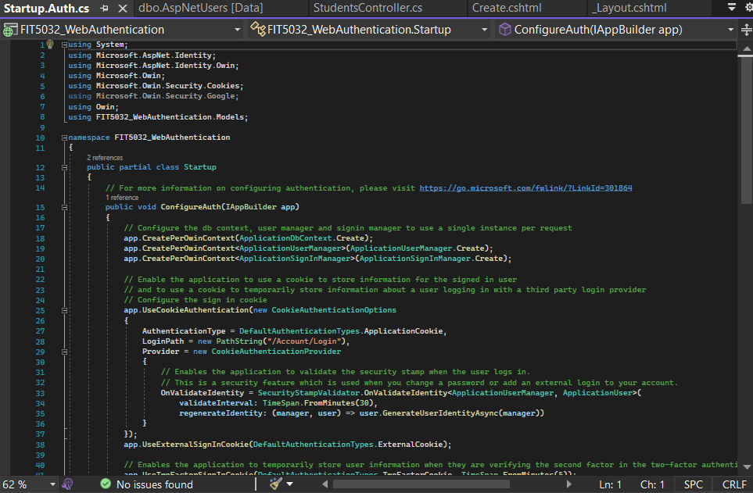

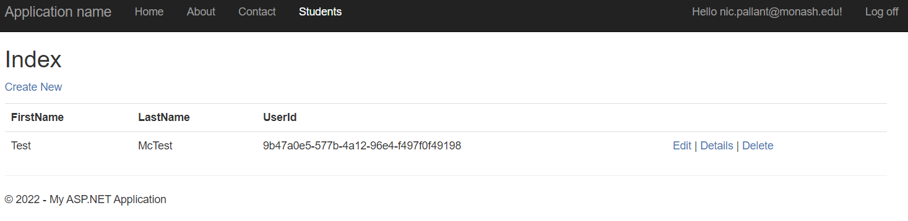

{Answers}

{Screenshots}

{Link to code repository}

{References}

{URLs}